How To: Naming Conventions
Naming your routines, loops and components is key in understanding your data once you have completed testing participants, so it is something that you need to consider prior to starting your project.
Your routines, loops and components cannot have the same names as one another so you must have unique names for each element. PsychoPy uses camelCase, which as you can see is lowercase followed by a capitalised suffix. Another thing that you need to be aware of spaces will not be recognised and will throw an error. If you want to have the illusion of a space then you should use an underscore (_)

Example
Let’s imagine a routine where we are presenting a stimulus and expecting a keyboard response. The response is the data we will be analysing (typically using the reaction time and accuracy data, but this depends on the type of study).
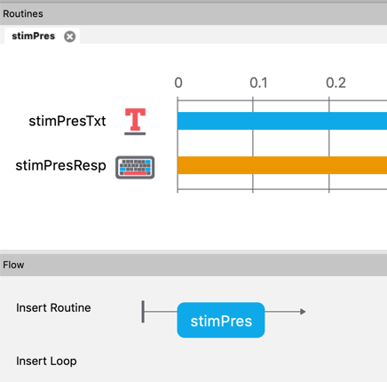
- Create a new routine and call it stimPres
- stim because it is identifying the content of the routine
- Pres to identify the purpose of the routine
- Add a text component to the routine and call it stimPresTxt
  - stimPres taken from the routine and keeping consistency in naming
  - Txt to show that your stimulus is of the text kind
- Add a keyboard component and call it stimPresResp
  - stimPres taken from the routine and keeping consistency in naming
  - Resp to identify that your component is your response element

In the resulting data file, you will be able to identify the data that you are interested in easily.
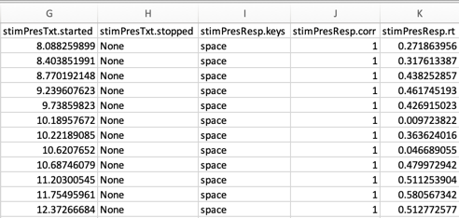
stimPresTxt.started = time of stimulus onset
stimPresResp.keys = key pressed by the participant
stimPresResp.corr = correct or incorrect (1 is correct, 0 is incorrect)
stimPresResp.rt =reaction time to target stimulus

